Welcome to the Escambia River Gun Club! The Escambia River Gun Club (ERGC), originally established as the Escambia River Muzzle Loaders (ERML), exists to conduct and promote safe recreational shooting activities and to maintain our rights bestowed to us by the Second Amendment of the Constitution.
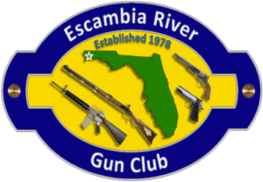
Since 1978, the ERGC has prided itself at providing a safe, first-class shooting facility that can be used for family outings, friendly competition, sighting the hunting rifle or just a relaxing afternoon of recreational shooting. ERGC is a private club intended for its members and guests. Applicants must be 18 years of age or older, and free of any felony convictions. An ERGC membership is a family membership covering the primary member, his or her spouse, as well as the member’s children under the age of 18.
Situated on 22 acres, all of ERGC’s ranges have covered firing lines and benches. An NRA-certified Range Safety Officer is present at all times during ERGC operating hours. Range safety rules apply to all members who are held responsible for their accompanied guests at all times.
ERGC’s members are the glue that hold the shooting club together. Many opportunities are available for members to use their skills and trades, not just on scheduled workdays, but also with behind-the-scenes committees that help plan events and future needs. The insatiable desire for competition can be fulfilled on any given weekend at ERGC by a wide variety of shooting contests, some pure accuracy while others thrive on speed. So whether your visit is for relaxation, practice, education, competition or recreation, ERGC has something to please just about everyone!

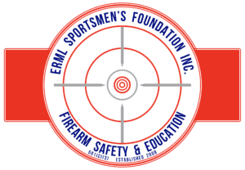
The Escambia River Muzzleloader Sportsmen’s Foundation (ERML), Incorporated (referred to as the “Foundation”), is an Internal Revenue Service designated 501(c)3 non-profit organization established as the educational branch of the Escambia River Gun Club.
Why a second corporation? Because the opportunities provided by a 501(c)3 greatly expand what ERGC can accomplish as a 501(c)7 (social organization).
The goal of the ERGC (the 501(c)7 corporation) is to establish a range to conduct and promote safe shooting activities and to maintain our rights as accorded us by the Second Amendment of the Constitution.
The goals of the Foundation are three-fold:
- To promote community interest and welfare by educating the citizenry in the safe handling, storage and proper use of firearms through scheduled events;
- To provide a range, to be known as the ERML Sportsmen’s Foundation Range, wherein citizenry will be able to develop firearm and archery shooting skills through scheduled programs for recreation, for competition and for developing firearm proficiency as required to secure State of Florida Conceal Carry Permits and Hunting Licenses;
- To promote education opportunities within the community via scholarship program emphasizing the U.S. Constitution, Second Amendment’s right to own, carry, and use firearms for personal safety, recreation and competition activities.

